**GROUP PROJECT, GROUP 3**

**DATE: 29 October 2018**

**TIME: 15:45 – 17:30**

**ATTENDEES** Tom Gibbs, Henry Crofts | Dave Pimm

**LOCATION:** A216, ATRIUM

**Minute Taker: Tom Gibbs**

**Overall aims of the current sprint *(Detailed tasks, user stories and time allocations are tracked on JIRA)***

* Define demographic, with cited statistics
* From demographic, define psychographic
* Review scope of project
* Amend and reformat design document
* Amend and reformat risk assessment
* Continue to attend studio jam sessions for team efficiency and clarity
* Book tutor meetings to review progress and project design
* Populate JIRA with backlog of User Stories to achieve MVP
* Edit model/produce models of game elements which are essential for main game mechanics

**Meeting:**

All team present.

Team reviewed feedback from the mornings sessions with Dan and Rob, as well as the afternoons arranged session with Dave.

Dave’s feedback resonated with the team. Dave’s advice made the team aware that to compensate for lacking in knowledge of design theories before beginning the project, the team had made efforts to devote time to researching design theories applicable to the game and implementing as many of these as possible.

The team had become oblivious to the fact that adding design mechanisms to hook the player had dramatically extended the scope of the project beyond the limitations the team initially imposed on themselves.

Team are certain that reducing the scope of the project to the ’10-minute experience’ is the best approach in terms of project completion given the team size and lack of art capability as well as to produce the most polished player experience possible.

Team reviewed current game design, using the design document produced in the previous sprint. Team began organising the design document sections into three groups: out of scope, in scope, and out of scope with design principles that can still be applied to the redesign.

Primary areas of concern were identified within the rescoping of the project:

* Reward scheduling
* Rewards to be earned
* Level design/progression damage

With these areas in mind – as well as tutor’s advice, the team decided on the weeks tasks and negotiated task times.

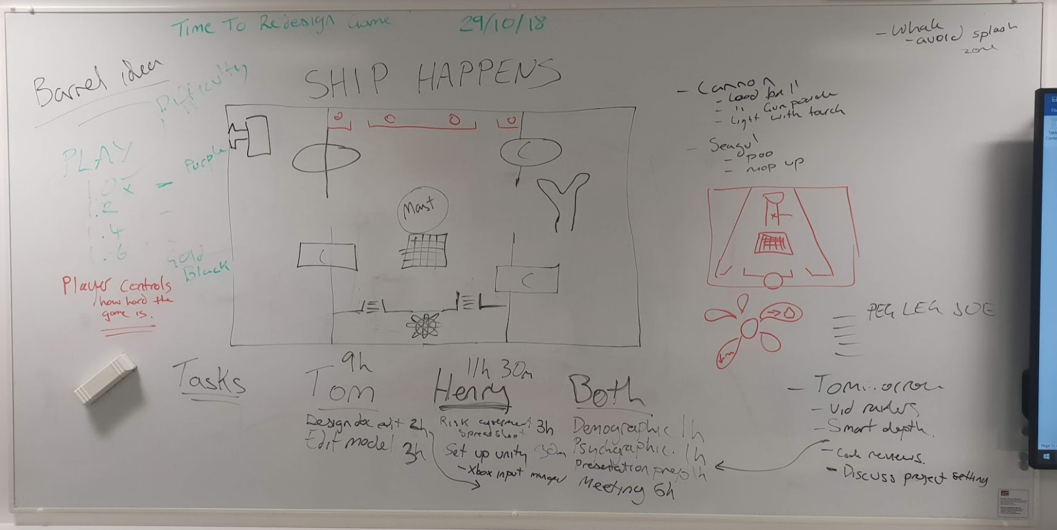

Team agree that the highest priority task is this week’s studio jam. The jam will be used in its entirety to rescope the project and ensure both team members share an understanding of the project goals.

Team had to cut meeting short because of time and outside of uni commitments. Meeting hours will be logged against the ‘studio jam’ task.

Team agreed not to begin work on any tasks until studio jam and definitive rescoping have taken place.

Team will continue the meeting tomorrow – meeting arranged for 30/10/18 @ 14:00.

**Tasks for the current week:**

**Tom (13h):**

* **As suggested by Dan spend time in the labs as a team in a game jam setting to increase team efficiency (6h)**

Dan Mayers agreed that we would benefit from spending time together in the labs to work together in a game jam / studio environment especially during the design phase.

Team will use this time to respond to Dave’s feedback, redefining the project scope and making sure design choices are still appropriate.

* **Amendment of the Design Document - to be completed as team (1h)**

Team must edit the design document as per the recent design updates to ensure mutual understanding and clarity to shareholders.

* **Define Demographic - to be completed as team (1h)**

Team must provide evidence supporting the design’s established target market. Upload word document to group repository.

* **Define Psychographic - to be completed as team (1h 30m)**

Team must produce an example member from the target demographic to aide and inform in the future design choices of the projects future. Upload word document to group repository.

* **Ship model must be edited as per the design document to allow suitable area for player interaction (2h)**

Edit low poly shit model allowing for player movement on the deck, with restricted and raised pathways as drafted in meetings and detailed in the design document. Upload model to group repository.

* **Bucket model must be produced as per the needs of the design document to allow for player interaction (30m)**

Produce low poly bucket model, suitable for receiving material colour in Unity. Upload model to group repository.

* **Mop model must be produced as per the needs of the design document to allow for player interaction (20m)**

Produce low poly mop model, suitable for receiving material colour in Unity. Upload model to group repository.

* **Torch model must be produced as per the needs of the design document to allow for player interaction (20m)**

Produce low poly torch model, suitable for receiving material colour in Unity. Upload model to group repository.

* **Barrel model must be produced as per the needs of the design document to allow for player interaction (20m)**

Produce low poly barrel model, suitable for receiving material colour in Unity. Upload model to group repository.

**Henry (13h 30m Hours):**

* **As suggested by Dan spend time in the labs as a team in a game jam setting to increase team efficiency (6h)**

Dan Mayers agreed that we would benefit from spending time together in the labs to work together in a game jam / studio environment especially during the design phase.

Team will use this time to respond to Dave’s feedback, redefining the project scope and making sure design choices are still appropriate.

* **Amendment of the Design Document - to be completed as team (1h)**

Team must edit the design document as per the recent design updates to ensure mutual understanding and clarity to shareholders. Upload word document to group repository.

* **Define Demographic - to be completed as team (1h)**

Team must provide evidence supporting the design’s established target market. Upload word document to group repository.

* **Define Psychographic - to be completed as team (1h 30m)**

Team must produce an example member from the target demographic to aide and inform in the future design choices of the projects future. Upload word document to group repository.

* **Complete production of Risk Assessment (2h)**

Continue assessment of project risks, upload word document to group repository.

* **As per Dan Mayers feedback, reformat Risk Assessment into Excel spreadsheet (2h)**

Import Risk assessment into Excel document as per Dan’s feedback, to detail risk impact and allow for future revisions. Upload Excel document to group repository.

***Detailed tasks, task descriptions, user stories and time allocations are tracked on JIRA.***